|  |  |
| --- | --- |
| **Project – External Documentation** |  |
| <BA03 – COMP6800001>  <Human and Computer Interaction> |
| <Even> Semester Year <2023/2024> |

Jennifer Angelique Wijaya <2602085290>

* Project Title

**WILLIFY**

* Intoduction

Willify adalah sebuah website yang menjual lagu-lagu. User dapat membeli lagu-lagu yang tersedia di Willify. User dapat menikmati berbagai macam jenis music dan genre yang terdapat di Willify. Willify hadir menemani user dalam menjalani keseharian sambil mendengarkan lagu-lagu favorit dengan koleksi lagu yang luas dan memiliki kualitas terbaik. Rekomendasi yang diberikan kepada user sangat beragam sesuai dengan jenis music atau genre yang user sukai.

**Documentation :**

1. Register Page**A screenshot of a login form

   Description automatically generated**

Pada bagian ini user akan diminta untuk mengisi data diri berupa nama, email, password, umur dan gender. Validasi yang dipakai adalah untuk nama tidak boleh kosong atau empty, untuk email juga harus di isi, password harus minimal 8 karakter, umur minimal 12 tahun dan gender juga harus terisi.

1. Login Page

Pada bagian login user akan diminta untuk mengisi email dan password, jika user sudah terdaftar sebelumnya maka user dapat melakukan login. Namun jika user belum pernah memiliki akun atau belum terdaftar maka user diharuskan untuk melakukan register terlebih dahulu.

1. Home Page

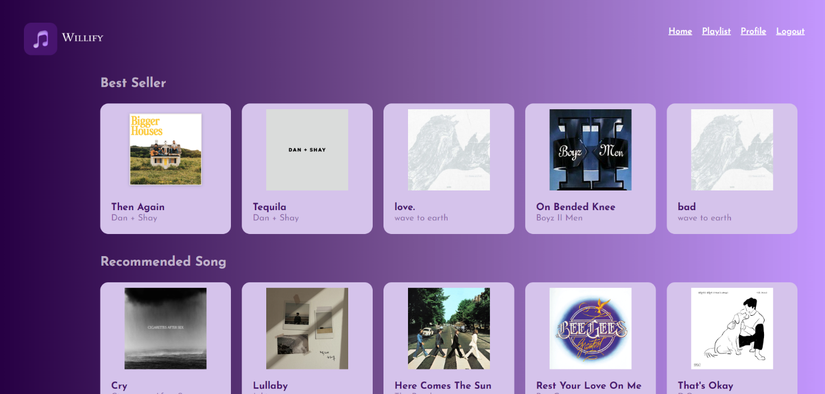

Pada home page, terdapat logo dan menu di bagian kanan. User dapat melihat lagu apa saja yang ,menjadi best seller dan rekomendasi lagu yang diberikan Willify kepada user. Juga terdapat icon about us di kiri bawah.

1. Playlist / Song Page

Pada page ini berisikan lagu-lagu yang sudah user miliki. Dan tiap song atau lagu yang dipilih user dapat berpindah ke page yang berisikan detail dari lagu tersebut.

1. Song Detail Page

Pada page ini, terdapat gambar dari lagu tersebut, judul dan artist. Lalu terdapat juga lirik lagu dan detail atau deskripsi mengenai artistnya.

REFERENSI :

1. <https://www.google.com/url?sa=i&url=https%3A%2F%2Fmusicrow.com%2F2023%2F07%2Fdan-shay-return-with-new-album-bigger-houses-set-for-fall%2F&psig=AOvVaw0vaQMptB5KpvGesR6FS5vc&ust=1717320358835000&source=images&cd=vfe&opi=89978449&ved=0CBIQjRxqFwoTCICQyYCLuoYDFQAAAAAdAAAAABAE> (Dan + Shay – Bigger Houses Album Cover)
2. <https://www.google.com/url?sa=i&url=https%3A%2F%2Fopen.spotify.com%2Falbum%2F0g1F5eGVwX4Sxi1n8ojPkE&psig=AOvVaw0vaQMptB5KpvGesR6FS5vc&ust=1717320358835000&source=images&cd=vfe&opi=89978449&ved=0CBIQjRxqFwoTCICQyYCLuoYDFQAAAAAdAAAAABAO> (Dan + Shay Album Cover)
3. <https://www.google.com/url?sa=i&url=https%3A%2F%2Fwww.koreanindie.com%2F2023%2F06%2F13%2Fwave-to-earth-0-1-flaws-and-all%2F&psig=AOvVaw3eCt-_OoaGJj2kIuu3F1in&ust=1717320450917000&source=images&cd=vfe&opi=89978449&ved=0CBIQjRxqFwoTCJjj96yLuoYDFQAAAAAdAAAAABAE> (wave to earth album cover)
4. <https://www.google.com/url?sa=i&url=https%3A%2F%2Fwww.alessandropuccinelli.com%2Fcigarettes-after-sex-new-album-cover%2F&psig=AOvVaw1IAXkceK_4Nm7XiC7eClN8&ust=1717320519502000&source=images&cd=vfe&opi=89978449&ved=0CBIQjRxqFwoTCKCs3c2LuoYDFQAAAAAdAAAAABAE> (CAS Album Cover)
5. <https://www.google.com/url?sa=i&url=https%3A%2F%2Fwww.discogs.com%2Frelease%2F4835853-Cigarettes-After-Sex-I&psig=AOvVaw1IAXkceK_4Nm7XiC7eClN8&ust=1717320519502000&source=images&cd=vfe&opi=89978449&ved=0CBIQjRxqFwoTCKCs3c2LuoYDFQAAAAAdAAAAABAJ> (CAS Album Cover)
6. <https://www.google.com/url?sa=i&url=https%3A%2F%2Fopen.spotify.com%2Fintl-id%2Ftrack%2F7MYmo0JJJDmu4MZTSAF9y3&psig=AOvVaw02efd93zIc3M1vOWqTWjtf&ust=1717320568670000&source=images&cd=vfe&opi=89978449&ved=0CBIQjRxqFwoTCIiWn-WLuoYDFQAAAAAdAAAAABAE> (Boyz II Men album cover)
7. <https://www.google.com/url?sa=i&url=https%3A%2F%2Fopen.spotify.com%2Ftrack%2F6cmdeeOEeyZG9YaJ1WRhnJ&psig=AOvVaw0UPh33G_jvQUVlDFOEVay3&ust=1717320596044000&source=images&cd=vfe&opi=89978449&ved=0CBIQjRxqFwoTCOD86PGLuoYDFQAAAAAdAAAAABAE> (Jukjae album cover)
8. <https://www.google.com/url?sa=i&url=https%3A%2F%2Fnews.detik.com%2Fbbc-world%2Fd-4658614%2Fthe-beatles-di-abbey-road-siapa-yang-mengambil-foto-mereka-menyeberang-jalan&psig=AOvVaw1DrXJ7nN_LIq1hGqX-ESXT&ust=1717320614777000&source=images&cd=vfe&opi=89978449&ved=0CBIQjRxqFwoTCIC3wvuLuoYDFQAAAAAdAAAAABAE> (The Beatles album cover)
9. <https://www.google.com/imgres?q=be%20my%20mistake%20lyrics&imgurl=https%3A%2F%2Fimages.genius.com%2F40bcd5cc419a7f4d283c62b7e181e156.1000x1000x1.png&imgrefurl=https%3A%2F%2Fgenius.com%2FThe-1975-be-my-mistake-lyrics&docid=noUIxzzNBo2tAM&tbnid=NvT7NRKmHRHDdM&vet=12ahUKEwiU4-mdjLqGAxWKzTgGHXAOBWAQM3oECGwQAA..i&w=1000&h=1000&hcb=2&ved=2ahUKEwiU4-mdjLqGAxWKzTgGHXAOBWAQM3oECGwQAA> (The 1975)
10. <https://www.google.com/imgres?q=the%20weeknd%20album%20cover&imgurl=https%3A%2F%2Fupload.wikimedia.org%2Fwikipedia%2Fen%2Fb%2Fbd%2FThe_Weeknd_-_Beauty_Behind_the_Madness.png&imgrefurl=https%3A%2F%2Fen.wikipedia.org%2Fwiki%2FBeauty_Behind_the_Madness&docid=sFxUs40IV7A_VM&tbnid=0qnOuP1B6SoJeM&vet=12ahUKEwjFs-qrjLqGAxUVxTgGHQefMMgQM3oECGsQAA..i&w=300&h=300&hcb=2&ved=2ahUKEwjFs-qrjLqGAxUVxTgGHQefMMgQM3oECGsQAA> (The Weeknd)
11. <https://www.google.com/url?sa=i&url=https%3A%2F%2Fwww.cbc.ca%2Farts%2Fdaniel-caesar-s-visual-brand-is-carefully-planned-but-this-stunning-album-art-was-a-stroke-of-luck-1.4573985&psig=AOvVaw1j8_qXCeKrcl6HuN5S5YCA&ust=1717320749041000&source=images&cd=vfe&opi=89978449&ved=0CBIQjRxqFwoTCLCf2LqMuoYDFQAAAAAdAAAAABAE> (Daniel Caesar)
12. <https://www.google.com/url?sa=i&url=https%3A%2F%2Fopen.spotify.com%2Falbum%2F6SWmGozzQDUaczHXMuE8Za&psig=AOvVaw2JfFCI_NI1YuFJpjWz2P5P&ust=1717320779860000&source=images&cd=vfe&opi=89978449&ved=0CBIQjRxqFwoTCKjXtcmMuoYDFQAAAAAdAAAAABAE> (LANY)
13. <https://www.google.com/url?sa=i&url=https%3A%2F%2Fid.wikipedia.org%2Fwiki%2FBrother_Act.&psig=AOvVaw0mugNxFBCdbMD0sEQYeYSz&ust=1717320817366000&source=images&cd=vfe&opi=89978449&ved=0CBIQjRxqFwoTCJCh59uMuoYDFQAAAAAdAAAAABAE> (BTOB)
14. <https://www.google.com/url?sa=i&url=https%3A%2F%2Fkpopreviewed.com%2F2018%2F11%2F18%2Falbum-hour-moment-btob%2F&psig=AOvVaw0mugNxFBCdbMD0sEQYeYSz&ust=1717320817366000&source=images&cd=vfe&opi=89978449&ved=0CBIQjRxqFwoTCJCh59uMuoYDFQAAAAAdAAAAABAI> (BTOB)
15. <https://www.google.com/url?sa=i&url=https%3A%2F%2Fen.wikipedia.org%2Fwiki%2FBrian_McKnight_%2528album%2529&psig=AOvVaw2_4UioEVUH2Tsjk2byPr3T&ust=1717320855115000&source=images&cd=vfe&opi=89978449&ved=0CBIQjRxqFwoTCKCxnO2MuoYDFQAAAAAdAAAAABAE> (Brian McKnight)
16. <https://www.google.com/url?sa=i&url=https%3A%2F%2Fwww.udiscovermusic.com%2Fstories%2Fquincy-jones-the-dude-review%2F&psig=AOvVaw3YMUJh6s1vx6rB-w2QVkhW&ust=1717320875230000&source=images&cd=vfe&opi=89978449&ved=0CBIQjRxqFwoTCODJ4faMuoYDFQAAAAAdAAAAABAE> (Quincy Jones)
17. <https://www.wikipedia.org/> (About artist)